Sun trap

The Sun is a star in the centre of the Solar System.
The Sun is as big as a million planets the size of Earth.
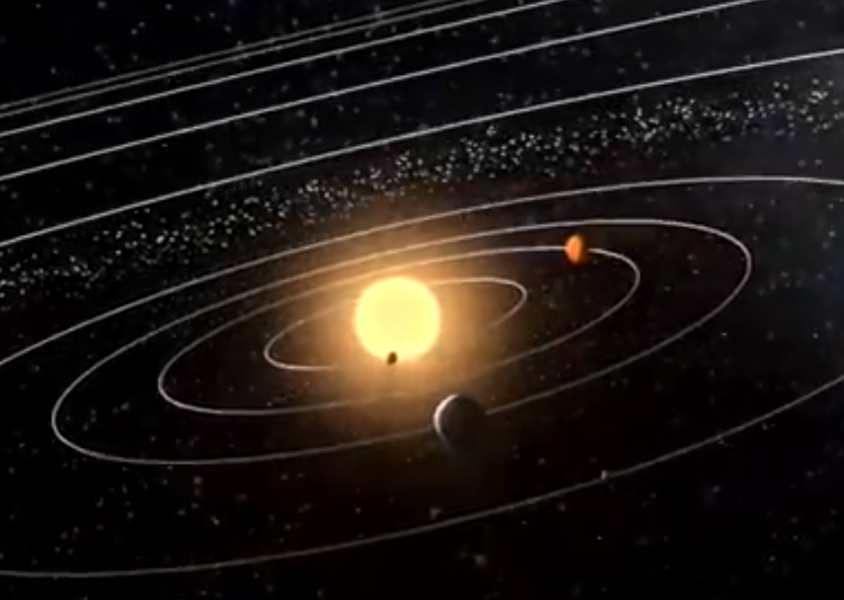

What do you think about the Sun’s gravity?
Which of these statements do you think are right?
For each statement, tick (✓) one column to show what you think.
 |  | I am sure this is right | I think this is right | I think this is wrong | I am sure this is wrong
A | The Sun has no gravity because it has no air
B | The Sun has a very big gravity because it has a huge mass
C | The Sun’s gravity reaches out deep into space
D | The Sun’s gravity pulls all the planets towards it
E | The Sun’s gravity stops the planets shooting off into space

Physics > Big idea PES: Earth in space > Topic PES1: Solar System and beyond > Key concept PES1.1: Gravity
Diagnostic question
Sun trap

Overview
Learning focus: | Gravity is the force that holds the Solar System together
Observable learning outcome: | - Explain how we know gravity exists in space and describe how its force of attraction decreases with distance.  - Explain how gravity pulls planets and moons around in their orbits.
Question type: | Diagnostic, confidence grid
Key words: | Gravity, space

B | BRIDGING  This diagnostic question probes understanding of ideas that are usually taught at age 14-16, to build a bridge to later stages of learning.

What does the research say?
A widespread view of gravity amongst 11-to-17-year-olds, is that it is a ‘holding’ force rather than a pulling force. This thinking is bound up with the idea that gravity is linked to the atmosphere, and with air pressing down to stop things floating away (Stead and Osborne, 1980; Driver et al., 1994). This can lead to the misunderstanding that there must be air for there to be gravity. This has implications for thinking about gravity acting in space, on other planets and on the Moon.
In a study Stead and Osborne found that 81% of 13-year-olds and 75% of 14-year-olds do not think there is gravity in space .
They also found that a third of 14-year-olds (n=257) think that gravity decreases with height, and many think it decreases far more quickly than it actually does. Another third of these 14-year-olds think that gravity increases with height (Stead and Osborne, 1980). Here students may be confusing the force of gravity with the store of gravitational energy, which does increase with height. Interestingly many of these students think that gravity only increases with height inside the Earth’s atmosphere (Driver et al., 1994).
This question investigates students’ thinking about the Sun’s gravity and its effect on the planets of the Solar System. It gives an opportunity for discussing how gravity decreases gradually with distance.
Ways to use this question
Students should complete the confidence grid individually. This could be a pencil and paper exercise, or you could use an electronic ‘voting system’ or mini white boards and the PowerPoint presentation.
If there is a range of answers, you may choose to respond through structured class discussion. Ask one student to explain why they gave the answer they did; ask another student to explain why they agree with them; ask another to explain why they disagree, and so on. This sort of discussion gives students the opportunity to explore their thinking and for you to really understand their learning needs.
Differentiation
You may choose to read the questions to the class, so that everyone can focus on the science. In some situations it may be more appropriate for a teaching assistant to read for one or two students.
Expected answers
Statements B, C, D and E are all correct. Statement A is wrong.
How to respond - what next?
If students suggest the Sun has no gravity because it has no air, then they can be shown a picture of objects on the Moon which has gravity but no air (e.g. Slide 3 of the PowerPoint for BEST diagnostic question: On the Moon).
In the solar system the planets orbit the Sun. If there was no force acting on them they would shoot off into space in straight lines, at constant velocities away from the Sun. This does not happen because the Sun’s gravity pulls each planet towards it.
The planets do not fall ‘down’ towards the Sun because they are already moving quickly in other directions. The effect of the Sun’s gravity is to pull each planet around in an orbit by continually forcing it to change direction. Each planet orbits at a distance away from the Sun at which the Sun’s gravity is just the right amount to pull it sideways into an orbit.
If students have misunderstandings about how the Sun’s gravity extends out into space and pulls the planets around in orbits, it can help to model the force of gravity by moving a ball on the end of a piece of string around in circles. The string pulls the ball towards the centre of the circle, but because the ball is moving, it is pulled in a circle. This model is explored in the following BEST ‘response activity’ which could be used in follow-up to this diagnostic question:
- Response activity: Modelling gravity
Acknowledgments
Developed by Peter Fairhurst (UYSEG)
Images: NASA's Scientific Visualization Studio
References
Driver, R., et al. (1994). Making Sense of Secondary Science: Research into Children's Ideas, London, UK: Routledge.
Stead, K. and Osborne, R. (1980). Gravity. Hamilton, New Zealand: LISP Working Paper 20, Science Education Research Unit, University of Waikato.

